**Team JHawk Maintenance Plan**

There are many factor to consider when determining maintenance costs for the “What To Play?” app. These include fees associated with hosting and selling the app through different app marketplaces and the cost of hiring an app developer.

In the case of app store fees, there are two major marketplaces for the app to be hosted in.: the Apple App Store and the Google Play store. The following chart was pulled from <https://developer.apple.com/support/compare-memberships/> on 12/6/2017.

Benefits and Resources

|  | **Sign in with Apple ID** | **Individual** | **Organization** | **Enterprise Program** |
| --- | --- | --- | --- | --- |
| Xcode Developer Tools | ● | ● | ● | ● |
| Xcode Beta Releases | ● | ● | ● | ● |
| Developer Forums | ● | ● | ● | ● |
| Bug Reporter | ● | ● | ● | ● |
| Test on Device | ● | ● | ● | ● |
| Beta OS Releases |  | ● | ● | ● |
| Advanced App Capabilities |  | ● | ● | ● |
| App Store Distribution |  | ● | ● |  |
| In-house App Distribution |  |  |  | ● |
| Safari Extensions |  | ● | ● |  |
| Developer ID |  | ● | ● | ● |
| Technical Support Incidents |  | ● | ● | ● |
| Team Management |  |  | ● | ● |
| TestFlight Beta Testing |  | ● | ● |  |
| App Analytics |  | ● | ● |  |
|  |  |  |  |  |
| Cost | Free | 99 USD* | 99 USD* | 299 USD** |
| Requirement | 13+ | 18+ | DUNS Number | DUNS Number |

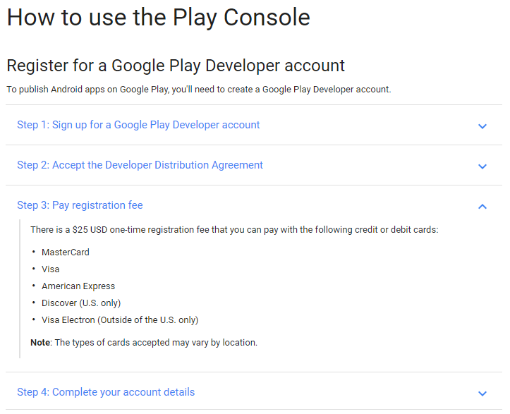As can be seen, a minimum of an Individual membership would be required in order to acquire the necessary resources to maintain the application. This will result in a $99 per year fee that would need to be paid. For the Google Play store, it is required to use the Google Play Console for which according to their website requires a $25 one-time fee.

There, between the App Store and Google Play, it will require an initial investment of $124 for the first year, though this will decline to $99 for each subsequent year.

The next major expense would be hiring an app developer to maintain and add occasional improvements to the app. This would also include the necessary work of updating the app whenever Boardgamegeek.com implements any API changes. According to <https://www.payscale.com/research/US/Job=Application_Developer/Salary> as pulled on 12/6/2017, the median income of an app developer in the United States is $66,858.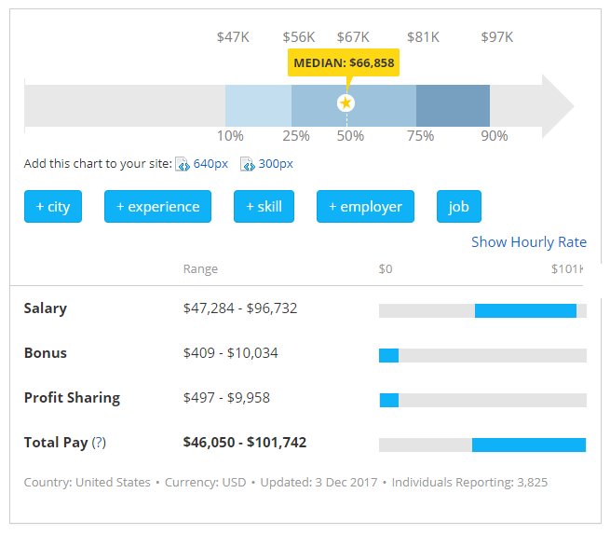

That figure though is based on a full time job. As the size of this application should not require full time development, it should be possible to find a free-lance app developer to work on a part-time basis for the application maintenance. In that case, looking at the hourly wage for an application developer, it can be expected to pay approximately $29.67 per hour.

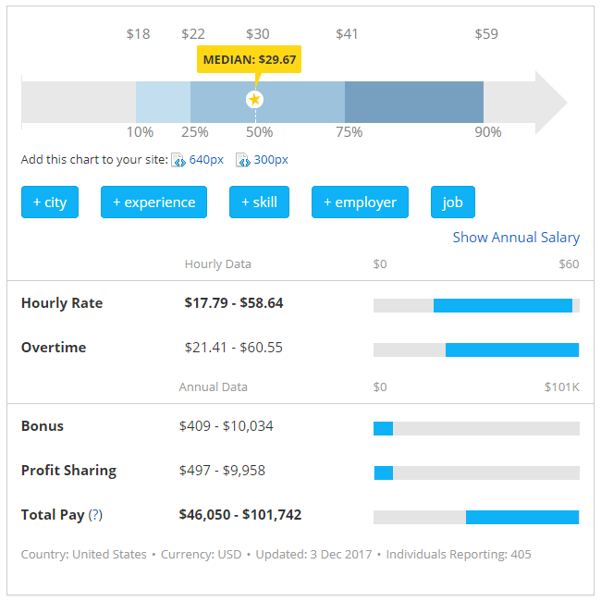

If it is assumed that the amount of work totals approximately 20 hours per week, this would result in:

$$52 weeks ×20 hours ×\$29.67=\$30,856.80 for the first year$$

This would drastically decrease the amount of money required to maintain the application.

Therefore, overall the maintenance cost for the first year could be expected to be approximately $30,980.80. Though, as can be seen from the wage range for an app developer and the as of yet unknown amount of actually hours required to maintain the app, this figure could be significantly less or more.